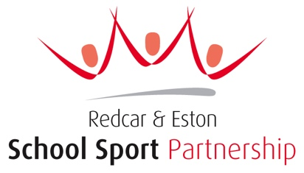
Redcar & Eston School Sport Partnership CIC
Hosted by Grangetown Primary School, St George’s Road West, Grangetown, TS6 7JA
Email: claire.tennyson@ressp.co.uk
Tel: 07921 952037

May/June 2023
Partnership Assistant Post
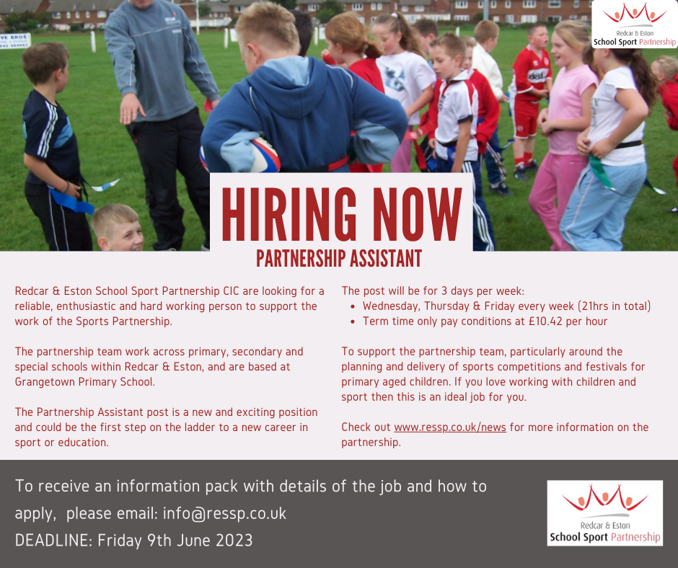
Thank you for requesting further information on the new Partnership Assistant Post.
This post has been created to give extra capacity to the Partnership Team, predominantly supporting the School Sport Officer to plan and deliver the competitions and festivals we organise for primary schools within the School Sport Partnership.
Who we are?
The partnership has been running for 17 years and in 2020 changed its legal status to a Community Interest Company. We are based at Grangetown Primary School but work across all the partnership schools within the Redcar & Eston geographical area.
We aim to encourage more children and young people to be and stay active. To help achieve this aim, we support schools to increase and improve the quality of physical education, school sport and physical activity opportunities. To get a flavour of what we do you can visit the partnership website at www.ressp.co.uk or through our social media channels: Facebook: @RedcarEstonSSP or Twitter: @RedcarEston_SSP
The Partnership Assistant will have a one-year contract initially, subject to funding. The person will be contracted to work 21hours per week across three days (Wednesdays, Thursdays and Fridays). This is a term time only contract so the successful candidate will not have to work in the school holidays. The rate of pay is £10.42 per hour.

General Responsibilities of the post:
- Support the School Sport Officer in the administrative tasks of planning a competition.
- Support the School Sport Officer in the setup of competitions and festivals.
- Support the School Sport Officer in the delivery of the competitions and festivals.
- To behave and conduct themselves in an appropriate manner working within schools and with children and young people.
- To ensure the high standards of the partnership are met.
- To take part in other partnership work when needed.

Person Specification: (E = Essential, D = Desirable)
- High level of personal skills and qualities: Hardworking, reliable, honest, empathetic, trustworthy, friendly and can work as part of a team. (E)
- Experience of working with children and young people. (D)
- A good understanding of sport and physical activity. (E)
- Be able to travel to the office base and around the partnership schools and events. (D)
- A good level of communication skills – oral and written (E)
- Competent in Microsoft Word, PowerPoint etc (D)
- Complete the appropriate Disclosure and Barring Checks needed to work with
- children and young people. (E)
How to apply: 
Please send a letter of application telling us why you would like to be our Partnership Assistant and what would make you a good candidate. Also attaching your current up to date Curriculum Vitae.
Please email the letter and the CV to: info@ressp.co.uk NO LATER than Friday 9th June at 3pm.
If you have any questions at all, please do not hesitate to email them through before you apply at info@ressp.co.uk.
Good luck in your application.
Yours Sincerely
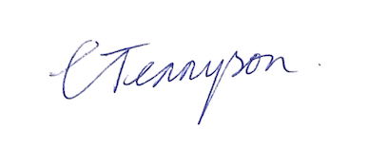
Claire Tennyson
Executive Director
Redcar & Eston School Sport Partnership CIC
Redcar & Eston School Sport Partnership CIC is a registered Community Interest Company. Company number 12526434

